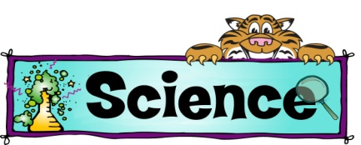
Physical
Course Outline

Introduction: What is Physical Science
Safety
Scientific Method
Graphing

Chapter 1: Introduction to Matter
Classifying Matter
Measuring
Changes in Matter

Chapter 2: Solids, Liquids, and Gases
States of Matter
Phase Changes
Behavior of Gases

Chapter 3: Elements and The Periodic Table
The Atom
Periodic Table
Metal, Nonmetals, and Metalloids

Chapter 4: Atoms and Bonding
Why atoms combine
Types of Bonds (ionic vs. covalent)
Metals, nonmetals & metalloids

Chapter 5: Chemical Reactions
Chemical changes
Chemical equations
Chemical reactions and energy

Chapter 6: Solutions and Acids, Bases & Salts
Parts of a solution
Solubility and concentration (solubility curves, types of solutions, electrolytes)
Acids and bases
pH scale and indicators

Chapter 7: Motion and Speed
Motion, speed and velocity
Acceleration
Motion and forces

Chapter 8: Forces and Newton’s Laws of Motion
Force and friction
Inertia the laws of motion
Momentum, free fall, centripetal force
Buoyant force

Chapter 9: Work and Machines
Work and power
Machines and their uses
Simple machines

Chapter 10: Energy
Forms of energy (kinetic vs. potential)
5 types of energy
Law of conservation of energy

Chapter 11: Thermal Energy and Heat
Temperature and heat
Three types of heat transfer
Insulators and conductors

Chapter 12 & 13 Waves and Sound
Types of waves
Parts of a wave
Interactions of waves (reflection, refraction, diffraction)

Chapter 14: Electromagnetic Waves
What are electromagnetic waves
The electromagnetic spectrum
Types of electromagnetic waves

Chapter 15: Light
Light and color (prisms, refraction)

Chapter 16: Electricity
Electric charge (static electricity, conductors, insulators, lightning)
Electric current (resistance, batteries)
Electric circuits

Chapter 17: Magnetism
Magnetism (poles, magnetic field, compass)

